**Table of Contents**

Abstract i

List of Figures ii

Abbreviations iii

Chapter 1: Introduction 1

1.1. Background 1

1.2. Objectives 2

1.2.1 Primary Objectives 2

1.2.2 Secondary Objectives 2

1.3. Motivation and Significance 3

Chapter 2: Related Works/ Existing Works 4

2.1 TCP- The Connect Plus 4

2.2 BYJU’S 5

2.3 SutiDMS 6

Chapter 3: Procedure and Methods 7

3.1 Methodology 7

3.1.1 Research and Study 7

3.1.2 Front-End 7

3.1.3 Back-End 7

3.1.4 Testing and deployment 8

3.2 System Architecture 9

3.2.1 Use Case Diagram 9

Chapter 4: System Requirement Specification 10

4.1 Software Specification 10

4.1.1 Front-End Tools: 10

4.1.2 Back-End Tools: 10

4.2 Hardware Specification 10

Chapter 5. Project Planning and Scheduling 11

APPENDIX 13

References 13

# Chapter 1: Introduction

## 1.1. Background

Availability of various online platforms has developed the concept of virtual learning but there are very few school management systems available that would benefit the teachers, students and parents.This project entitled “Kinder” will be an online school management system that will be accomplished through Django, HTML, JS and CSS.

Every school/college has a different way of organizing their classrooms but there is merely any system to monitor the activities of small children basically the ones still in the Kindergartens. So, our goal here is to create a centralized platformwhere the activities of those students can be monitored or tracked easily. This would certainly help the parents to know about the current status of their children, keep track of their school activities and progress and also let them communicate with the teachers. The students will be able to easily receive and keep track of their assignments. This will also allow the parents of the children to get to know each other which is also really important.

Similarly, the teachers would also have an easy way to inform the parents about their child’s problems so that the parents can deal with the problems efficiently. Thus, this project is fully focused on managing the schooling of small kids with the help of parents-teachers collaboration.

## 1.2. Objectives

### 1.2.1 Primary Objectives

* To provide an easy-to-use interface, robust system to take on the challenge of running an educational system, and the flexibility to adapt to changing needs.
* To keep track of students’ performance, attendance and results.
* To maintain the data of all the students in a database.

### 1.2.2 Secondary Objectives

* To provide an online platform to check upon kids’ performance.
* To help increase parent-teacher collaboration.

## 1.3. Motivation and Significance

Through reviews and a simple research, we came to realize the obvious fact that there are really very few numbers of online school systems that help track the performance of small kids. The ones that are available are very poorly managed due to the irresponsibility of the school administration resulting either due to the complexity of services or noisy features on the service. As all of the team members are interested in a project to help and make it easier for all parents, teachers and students, so we choose “Kinder”. Realizing that there is a disconnection between students, parents and teachers in the modern connected world and also how hard it is for parents nowadays to make time to go to school to learn about their child’s school activities and progress and resolve their concerns about their child with their teachers. Since we couldn’t find any platform that does this effectively, we aim to create a platform for parents, students and teachers to interact with each other easily and make school easier for them all. Since not many schools provide such platform, parents have difficulty knowing their child’s school activity and progress so “Kinder” aims to solve this.

# Chapter 2: Related Works/ Existing Works

## 2.1 TCP- The Connect Plus

TCP (The Connect Plus) is an Educational Institution based software. It is a tool for institute for the real time updates of notices, attendance, diary, homework, assignments, routine, remarks, institute calendar, exam routines, exam syllabus, mark sheet, learning materials, events and activities, scheduler, educational news, invitation/greetings, my file, institute information, message from the Head of the Institute to the parents and students who can view it and take benefit of the updates.

This app mainly focuses on the higher level studies and the management of the curriculum and is merely useful for the parents of small children. So, in order to solve this problem we have planned to develop this interactive site for the sake of the better monitoring of the kids’ daily activities during school by their parents.

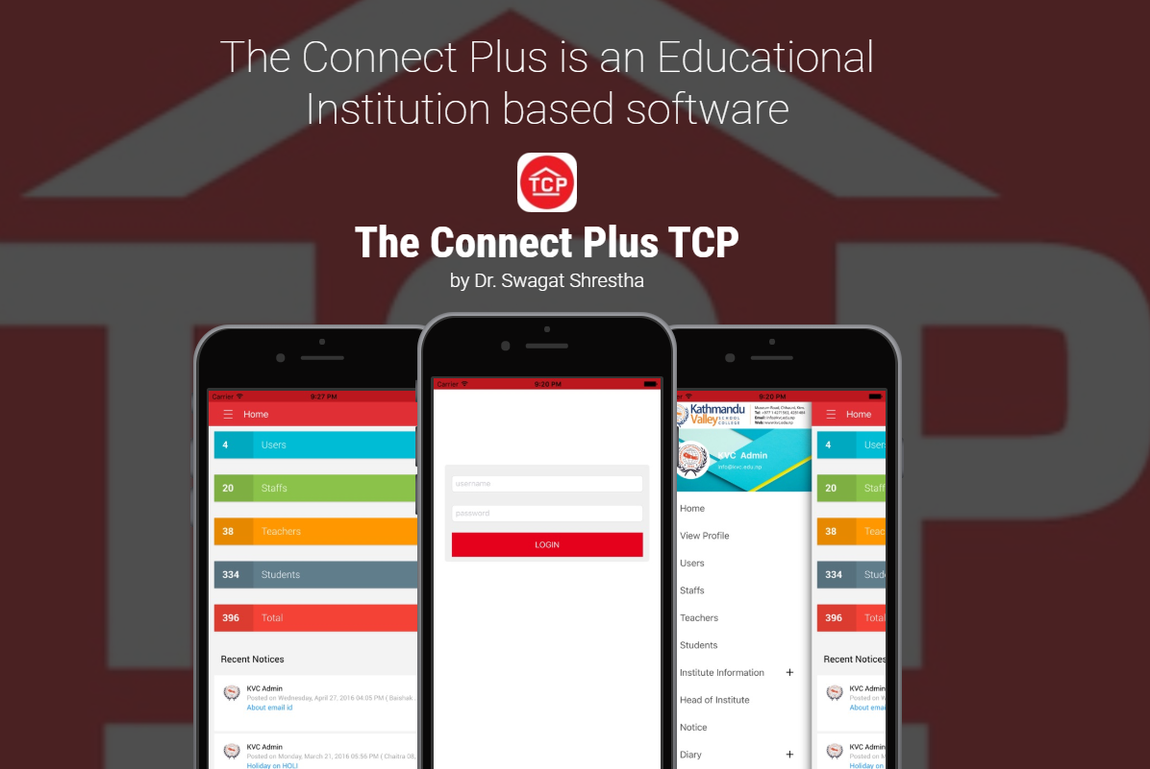

## 2.2 BYJU’S

It is the world's most valuable ed-tech company and the creator of India's most loved school learning in India. Launched in 2015, BYJU'S offers highly personalized and effective learning programs for classes 1 - 12 (K-12), and aspirants of competitive exams like JEE, CAT, IAS etc. With 35 million registered students and 2.4 million paid subscriptions, BYJU'S has become one of the most preferred education platforms across the globe.

Aspired from this, we also planned for the development of a simple website that would really improve the parent-teacher’s collaborative effort for the proper monitoring of the kids (primary level students)

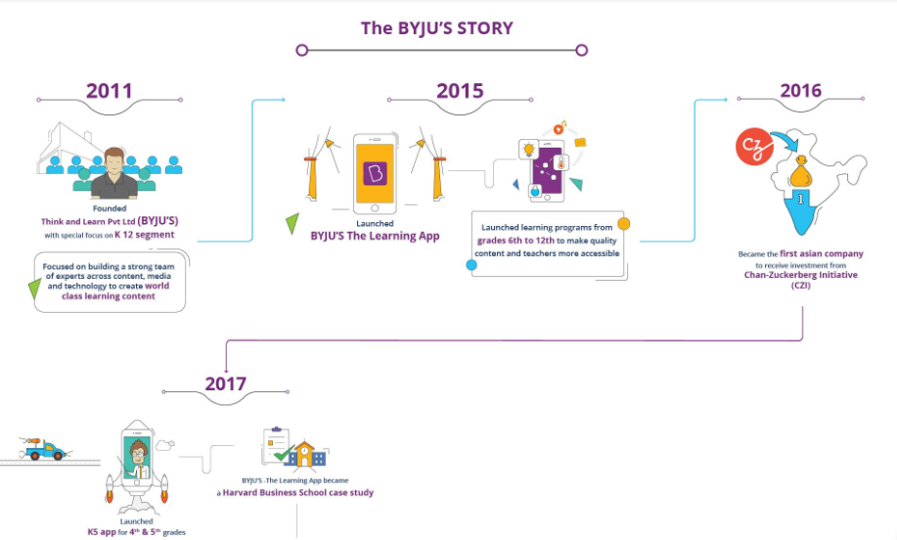

## 2.3 SutiDMS

It is an online document management software solution that lets users to organize, manage, share and communicate their business critical information. It comes with integrated modules that helps them with team collaboration, workflow management and approvals.

This software is especially based on business work but our site solely focuses on the improvement of the child’s education and development through better guidance. However, the database systems that we’ll use will be very similar to the system that this software uses.

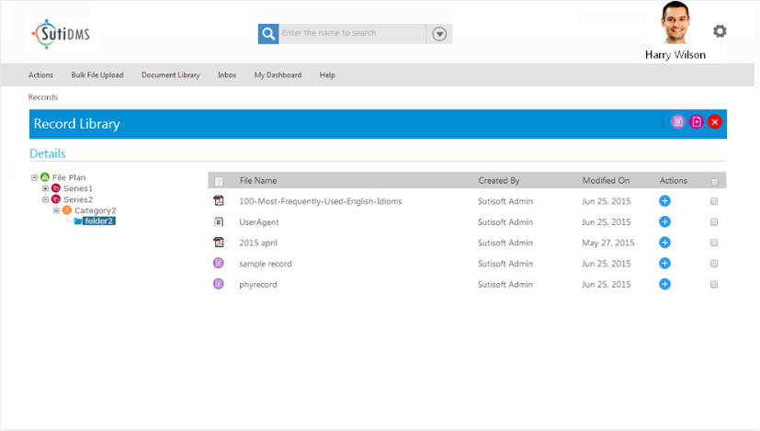

# Chapter 3: Procedure and Methods

## 3.1 Methodology

### 3.1.1 Research and Study

We will start by studying the various languages required for this project through various sources and sites. We will also search for various projects and system related to our project that are currently available on the internet and we will study the flow and use case of those systems. We will also analyze the features of the systems that we study and make a clear roadmap for our system flow and how those features are integrated into the system.

### 3.1.2 Front-End

After analyzing the platforms similar to our projects available over the internet, we will pick the best features which will be the backbone of our system. They will assist, improve and enhance the user’s experience and create an intuitive GUI. We will improve upon those features and their appearance to make it more pleasing if possible and add new options and layouts as per the requirement to make it easier for parents and faculty members to collaborate in our platform.

### 3.1.3 Back-End

During the development of the front end, we will also integrate the user interface with the logic required to make the platform run smoothly. With the use of languages like Django, MySQL and JavaScript we will try our best to make the front end perform as seamlessly as possible. Through study and research we will be making a clear map of how our system will look like and how the flow of the system will go for various types of users in the system as per their requirements and accessible features of the users, and develop a fully flexible system that will run in as many platforms as we can develop.

### 3.1.4 Testing and deployment

To check for bugs in the system we will be periodically running the code to search for them, find them and make sure to eradicate them from the system to make the platform smooth and bug free. After that we will deploy our system to make it available for students, teachers and parents.

## 3.2 System Architecture

### 3.2.1 Use Case Diagram

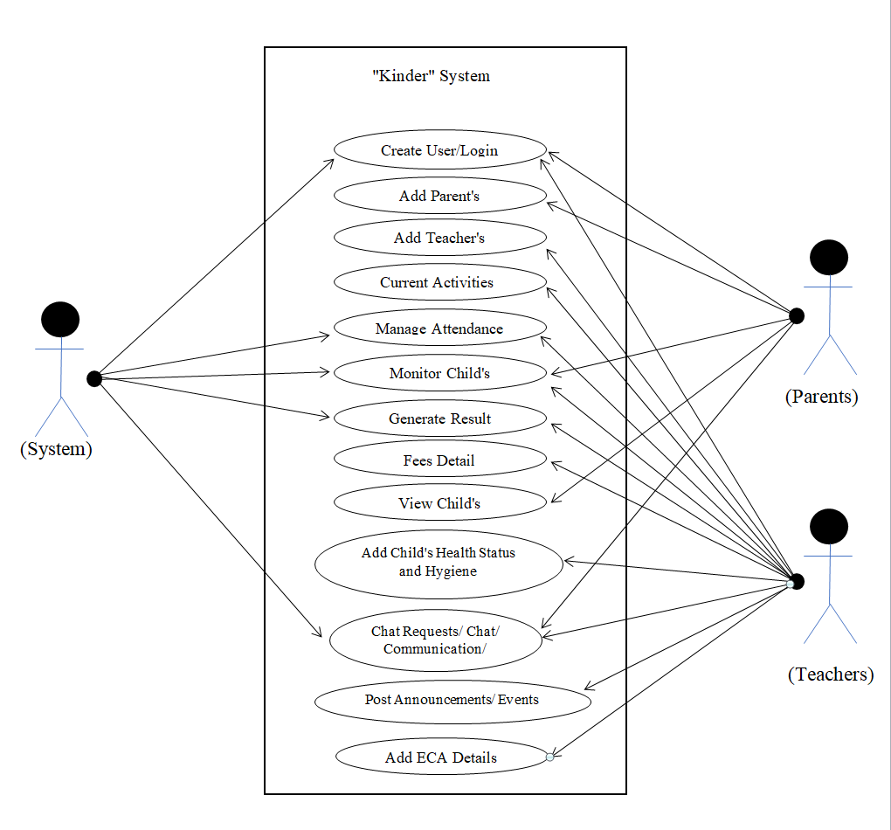

Figure 4: Use Case Diagram

The diagram above is a representation of a user's interaction with the system that shows the relationship between the user and the different features in which the user is involved. Here, the system will manage the activities that would include different calculations, database handling and communications. The teacher will frequently update different sections in the site so that the parents can easily look at the development of their children from home.

# Chapter 4: System Requirement Specification

## 4.1 Software Specification

### 4.1.1 Front-End Tools:

1. HTML
2. CSS
3. JavaScript

### 4.1.2 Back-End Tools:

1. Django
2. JavaScript

## 4.2 Hardware Specification

* A PC with minimal specs:
  + RAM: 1 GB or higher
  + SSD Storage: 24 GB(min)
  + CPU Core: 1

**OR**

* A smart phone with internet accessing facility.

# Chapter 5. Project Planning and Scheduling

This project is a unique approach to creating a school management system for children to help their teachers and parents. It is a pretty basic concept but very effective and practical idea for daily use. We have intended to complete this project within the time frame of 2-3 months. We have divided the process of project development into 3 phases- beginning, coding and developing phase and finally correction phase.

Beginning phase will be a month long or less where we will develop a basic framework of the project. Within this phase, we will develop a very basic program just to get things started. The second phase is the coding and developing phase and it will be the longest phase amongst all. It is within this timeframe where we will take the basic program from just being basic to a user friendly and interactive website. The final phase will be the correction phase where all the editing takes place.

The following Gantt chart represents the time frame we have allocated to complete our project by the end of the semester:

|  |  |  |  |  |  |  |  |  |  |  |  |  |
| --- | --- | --- | --- | --- | --- | --- | --- | --- | --- | --- | --- | --- |
| **Week**  **Work** | 1 | 2 | 3 | 4 | 5 | 6 | 7 | 8 | 9 | 10 |  |  |
| Research and Study |  |  |  |  |  |  |  |  |  |  |  |  |
| Front End |  |  |  |  |  |  |  |  |  |  |  |  |
| Back End |  |  |  |  |  |  |  |  |  |  |  |  |
| Program Testing |  |  |  |  |  |  |  |  |  |  |  |  |
| Documentation |  |  |  |  |  |  |  |  |  |  |  |  |
| Presentation Preparation |  |  |  |  |  |  |  |  |  |  |  |  |

**Fig 5.1** Gantt chart

# APPENDIX

# References

Tutorialspoint, (2019, 11 11). *Tutorials-Django.* Retrieved from:

[**https://www.tutorialspoint.com/django/index.htm**](https://www.tutorialspoint.com/django/index.htm)

W3C. (2019, 11 11). *Learn HTML*. Retrieved from W3Schools:

[**https://www.w3schools.com/html/default.asp**](https://www.w3schools.com/html/default.asp)

W3C. (2019, 11 11). *Learn CSS*. Retrieved from W3Schools:

[**https://www.w3schools.com/css/default.asp**](https://www.w3schools.com/css/default.asp)

Tutorialspoint, (2019, 11 11). *Tutorials-MySQL.* Retrieved from:

[**https://www.tutorialspoint.com/mysql/index.htm**](https://www.tutorialspoint.com/mysql/index.htm)

W3C. (2019, 11 11). *Learn JS*. Retrieved from W3Schools:

[**https://www.w3schools.com/js/default.asp**](https://www.w3schools.com/js/default.asp)